Importance Sampling Analysis for Credit Models

# Description of the Problem:

This document covers the “importance sampling performance” impact on Merton Multi-Factor Credit models based on Monte Carlo solvers.

Given the discontinuous nature of the Monte Carlo paths (an obligor is either in default or not depending on whether its associated factor model breaches the default probability barrier), the convergence of Credit risk models requires long simulation times before convergence is reached.

# Synthetic Portfolio under study:

Based on [1] we construct a portfolio with m=1000 obligors and d=10 factors, with the following parameters:

* Exposures $c_{k}=\sup\left({\left[\frac{5k}{m}\right]}^{2}\right), k∈(1..m)$
* Marginal defaults $p_{k}=0.01\sin{\frac{16πk}{m}}, k∈(1..m)$
* Factor loading $a_{ij}=Uniform\left(0,1/√d\right), i∈\left(1..m\right), j∈(1 .. d)$

The loss distribution of this portfolio is depicted in the following picture

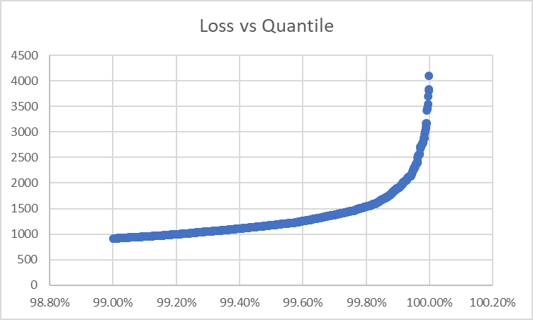

Figure Portfolio loss per quantile

We can observe that losses over 1000 will be in the tail with quantiles over 99%, which matches our current case of study for Credit ERC simulations.

# Convergence Studies, Accuracy:

In our approach we apply importance sampling to the distribution of the factors, by calibrating the necessary translations to be applied to each factor to approach our Multi-Variate sampling to the tail of the loss distribution.

After having calculated the factor shift for a nominal loss of 1000 (99%), we apply importance sampling to calculate $P(L>x)$ with $x∈[1000 .. 5000]$. Standard Monte Carlo and Importance Sampling MC simulation results, (with 1000 simulation paths), are depicted in the next figure.

Figure P(L>x) computed for MC and MC with Importance sampling

The blue line corresponds to Standard MC simulation. The MC (blue) shows convergence errors all along the axis of losses, for instance, after P(L>2200) (quantiles >~ 99.98%) the calculated probability is zero meaning that not enough obligors have made default during the calculation.

The orange line shows better convergence due to the importance sampling technique.

The IS calibration is performed for a loss of 1000, however with only 1000 simulation paths the IS MC shows correct convergence behavior at higher confidence levels.

If we increase the number of simulations of the normal MC method to 10’000, we obtain a better convergence rate of the standard Monte Carlo, but at quantiles larger that 99.9% convergence of the method Standard Monte Carlo is still insufficient as it is depicted in the next picture:

Figure Number Simulations 10’000. MC vs MC with IS with 1000 paths

The convergence problems depicted above are common in Credit Risk models and simulations paths over 10M need to be used when using standard MC solvers on 99.97 quantile.

# Convergence Studies, Acceleration:

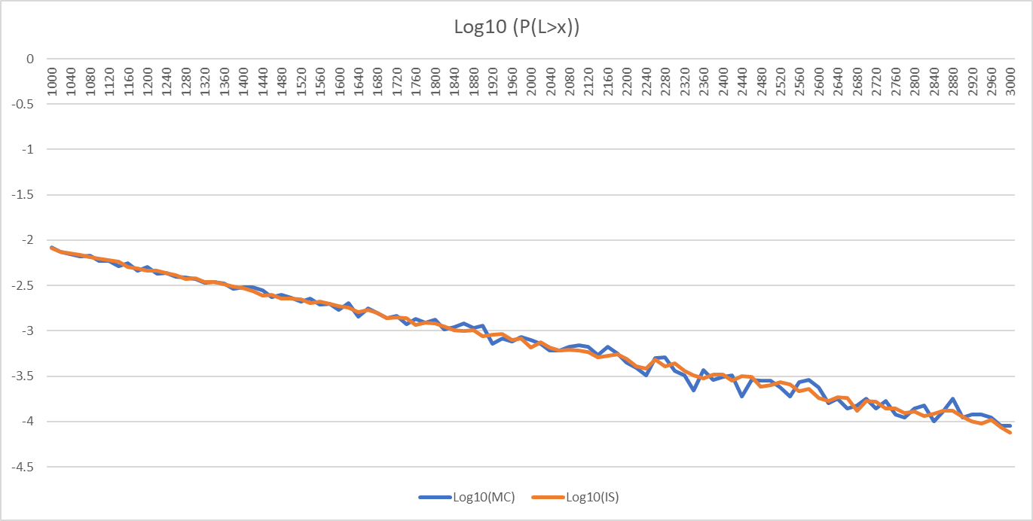

Figure MC simulation with 1M paths vs MC with IS and 1000 paths

# Technical Implementation:

The technical implementation of importance sampling has the following critical aspect in our opinion:

## Optimization Package:

Importance sampling needs to solve the following optimization problem:

$F\left(z\right)=\max_{z∈R^{d}}\left\{1.0-Φ\left(\frac{\left(1-E\left[L|Z=z\right]\right)}{√VaR\left(E[L|Z=z]\right)}\right)\right\}$,

where

$E\left[L | Z=z\right]=\sum_{i=1}^{m}{p_{i}c_{i}}$

$E\left[L | Z=z\right]=\sum_{i=1}^{m}{p_{i}\left(1-p_{i}\right)c_{i}^{2}}$

The problem is convex, however choosing starting values too shifted towards the tails of $Φ(\vec{x})$ make many optimization solvers to fail to find a solution due to the lack of gradient information.

From all the optimization packages we have tried, only NLOPT (written in C) could solve this problem showing stability in the computed results.

Any unconstrained method within the NLOPT would work to solve this problem, however we have selected Augmented Lagrangian algorithm including a boundary condition of positivity. This condition helps the solver to focus on the positive side of the loss distribution preventing the search to happen on the earnings side.

However, a starting point placed in a location of the target function with minimal gradient information needs to be provided.